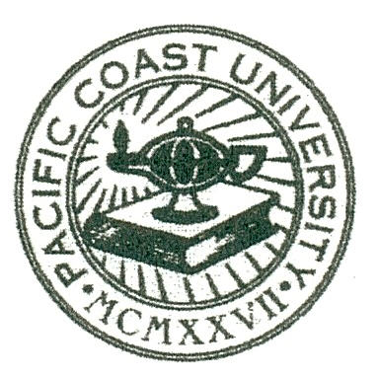
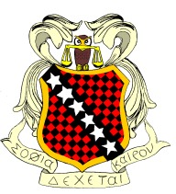
Alpha Xi Chapter of
Pacific Coast University
School of Law

SHOW YOUR PCU SPIRIT WITH YOUR VERY OWN

License Plate Frame
Top of Form
A real roadside attraction, get your driver's attitude or cause across on this cool License Plate Frame. Constructed of sturdy, durable, shiny chrome that makes your message POP. Images are applied with a permanent adhesive weatherproof decal. UV and water-resistant. Fits most cars. 12" x 6" Enhance the message of your vanity plate.
- Measures 12" x 6"
- Constructed of chromed steel
- Graphics are applied with permanent adhesive vinyl decals
- UV and water-resistant

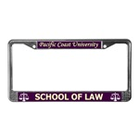
$20.00
Name: ______________________
Phone: ______________________

E-mail: ______________________
Quantity: ___________
Total: $ _____________

Pre-Sale Only! Please make checks payable to SDK and return this form along with payment to any SBK Officer by November 30, 2007. Don’t forget to join SDK. Ask any SDK officer for details. Join by December 01, 2007. December 01, 2007 – “SDK Spirit Day”.

Sponsored by
Alpha Xi Chapter of Sigma Delta Kappa Law Fraternity

