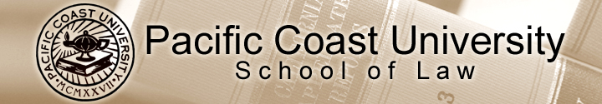

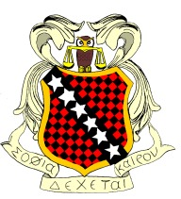
SDK will provide a free lunch at the Ontario Convention Center on Tuesday, June 24, 2008 for the PCU students who will be taking the June 2008 Baby Bar Exam.

The lunch will be catered by El Pollo Loco.

Look for the RED SDK Banner in the Patio Area.

You must turn in your lunch reservation by May 10, 2008 to the SDK box or any SDK officer. If you have questions, please e-mail Angela Ramos, SDK Chancellor @ Happyjolie@aol.com

Please return the bottom portion by May 10, 2008.
------------------------------------------------------------------------------------------------------------

Name: ____________________________________
Address:___________________________________
Phone No.: _________________________________
E-mail: ____________________________________

Yes, I would like SDK to bring lunch for me on Tuesday, June 24, 2008.

